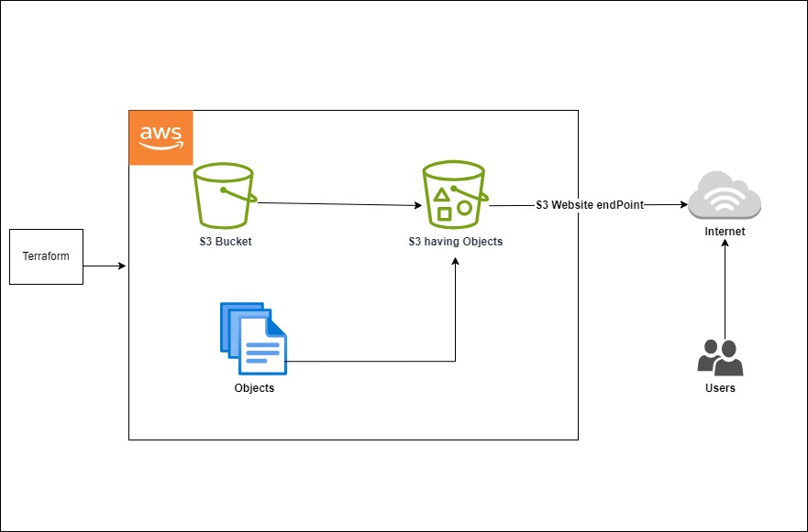

This project presents an efficient method for hosting a basic website by leveraging Terraform and Amazon Web Services (AWS) S3. The primary objective was to simplify the deployment process without unnecessary difficulty. Using Terraform, I made configuration outlining the infrastructure requirements for hosting the website on AWS S3. This Terraform configuration is necessary to set up and configure an S3 bucket for various purposes, such as storing files, hosting a static website, and managing access control and ownership settings. It ensures consistency and repeatability in deploying AWS infrastructure and helps manage resources in a structured manner.

Top of Form